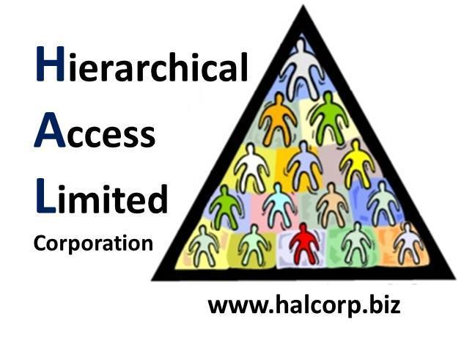

Internal Memorandum

**To:** CIO

**CC:**

**From:** TEAM A

**Date:** Oct 21, 2018

**Memo #: 5**

**Re:** Anti-Virus Software

Good Afternoon,

The software “Microsoft Security Essentials” has been installed on the system.

Attached below is the most recent scan done on the system.

If you have any questions, please let us know.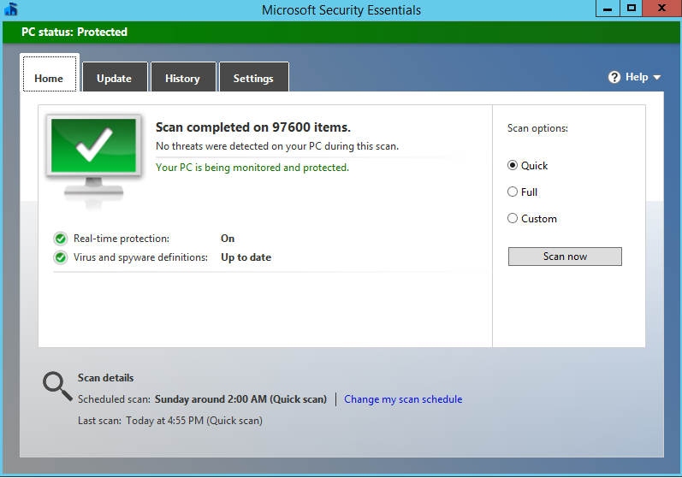

Regards,

Team A